**Web Development :**

**Home Page:** Entering the values in the fields to find the customer will **Churn or Not**.

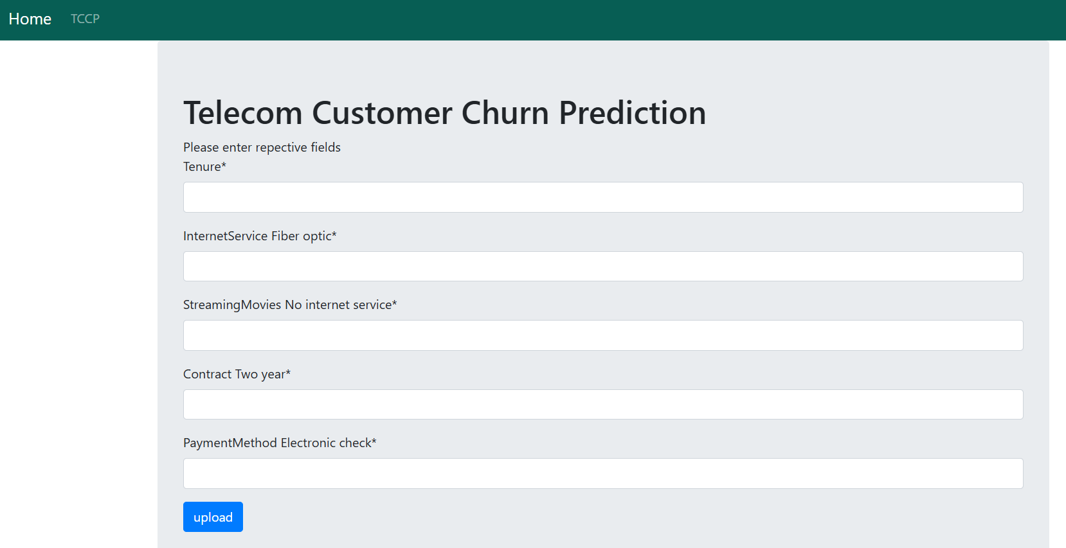

Example 1: Entering the fields based on below values, the customers will **Churn** .

* **Short tenure (0–12 months)**: High chance of churn. New users are more likely to leave early.

**Mid tenure (13–24 months)**: Moderate churn; users begin stabilizing.

* **Value = 1 (Fiber Optic)**: Higher churn risk compared to DSL due to potentially higher prices or service complaints.
* **Value = 1**: Indicates no internet service → churn depends on other factors, might be neutral.
* **Value = 0**: Month-to-month or one-year customers have higher churn risk.
* **Value = 1 (Uses Electronic Check)**: **Higher churn** probability. Often associated with less loyal customers.

**Output Page:**

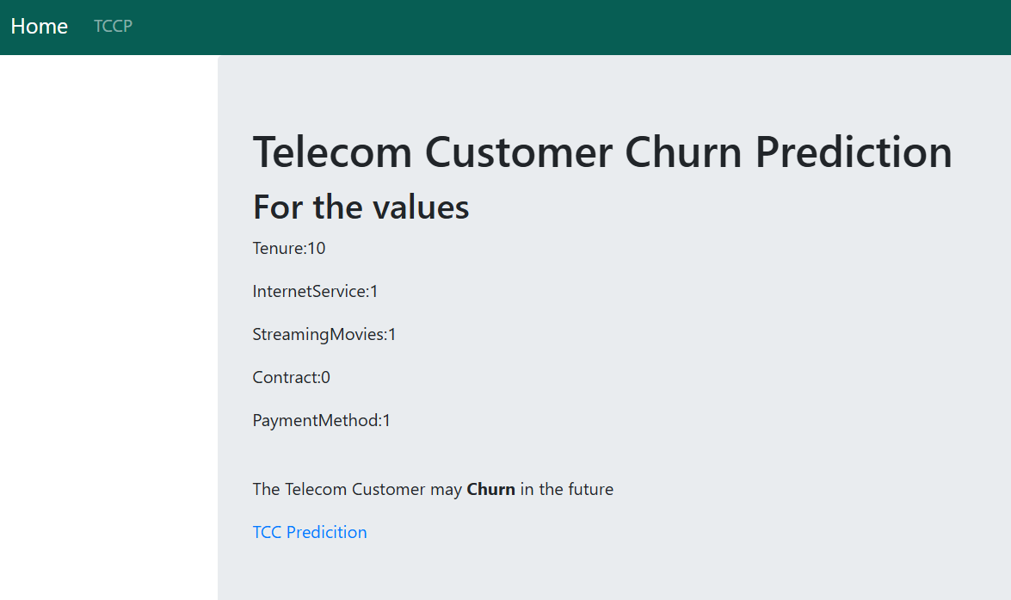

Example 2: Entering the fields based on below values, the customer will **Not Churn**.

* **Long tenure (>24 months)**: Low churn; loyal users typically stay.
* **Value = 0**: Lower churn risk if they use DSL or no internet service.
* **Value = 0**: If they do have internet (DSL/Fiber) → evaluate other streaming services. High add-on usage can reduce churn.
* **Value = 1 (Two-year contract)**: Very **low churn probability**. Long-term contracts usually indicate stable customers.
* **Value = 0**: Customers using auto-pay or credit cards tend to stay longer.

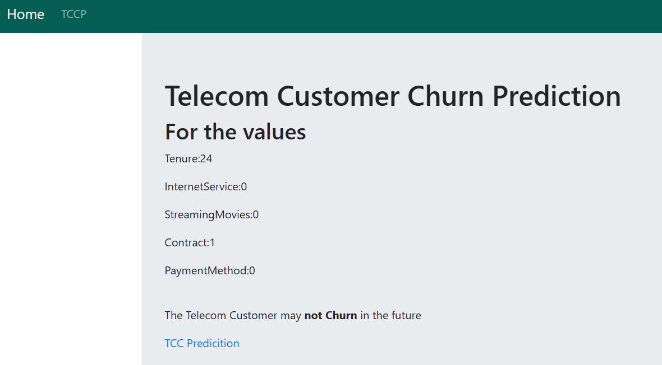

So based on other combination of values we can predict the customers may Churn or may Not Churn depends on the field which has higher probability of churn or not.